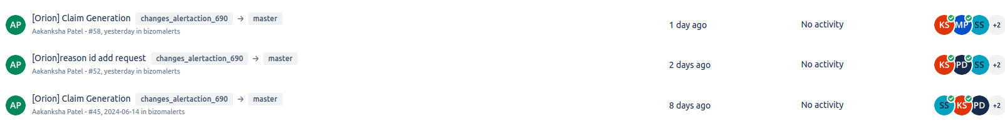
https://bitbucket.org/bizom/bizomalerts/pull-requests/45/commits
https://projects.zoho.in/portal/mobisy#taskdetail/15779000002340099/15779000003899297/15779000007769923

https://bitbucket.org/bizom/ell-backend/pull-requests/117
https://reportsbetanew.bizom.in/alertactions/edit/783
---------->>>>> Repetitive msg lines but approved
https://bitbucket.org/bizom/ell-backend/pull-requests/114
https://reportsbetanew.bizom.in/alertactions/edit/744
-------------->>>> $userQuery = "SELECT * FROM users WHERE id = 1"; but approved
https://bitbucket.org/bizom/ell-backend/pull-requests/113/overview
https://reportsbetanew.bizom.in/alertactions/edit/743
-------------->>>> $userQuery = "SELECT * FROM users WHERE id = 1"; but approved
https://bitbucket.org/bizom/bizomalerts/pull-requests/78
>>> personal mails
https://bitbucket.org/bizom/bizomalerts/pull-requests/80
>>> multiple print statements
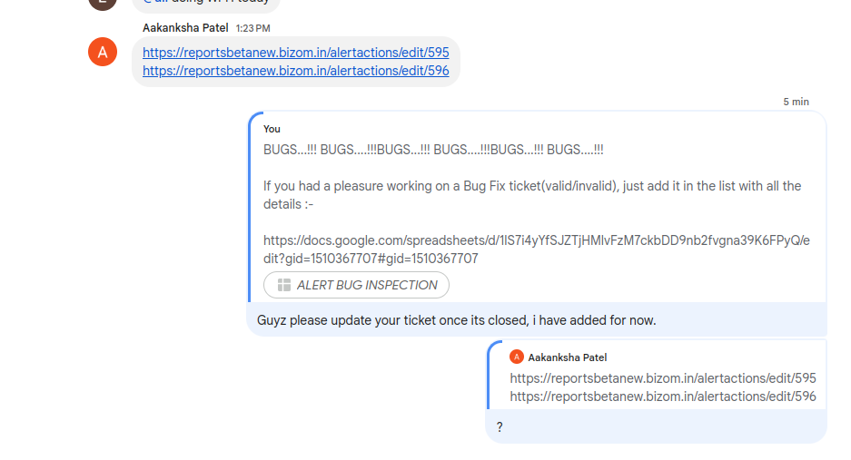
>>>>>Allegation are being put when we put anything in group
TGI datasource issue got highlighted , [Haleon] MRP and Price update alert did not get highlighted, the changes were done on 2024-07-25 07:09:35 (alertactionsrevisions)

